

Functional Area: CSA Portal

Screen Specifications

Document History
Version | Date | Description | Name
0.1 | 15/02/2006 | Initial draft | Nicholas Cole
0.2 | 19/02/2006 | Reviewed with the business.  Screens for Login, Locate Customer and Delete MTM account have been baseline. | Nicholas Cole
0.3 | 19/02/2006 | View Audit History Added | Nicholas Cole
0.4 | 23/02/2006 | Split out from whole system screen specification.  Baseline by Business | Nicholas Cole

1.1.1 Screens 3
1.1.1.1 Screen – Delete MTM Account 3
1.1.1.2 Screen – Confirm To Delete MTM Account 4
1.1.1.3 Screen – Delete MTM Account Confirmation 6

Screens

Screen – Delete MTM Account
This area will allow the CSA to delete a MTM account from the system.

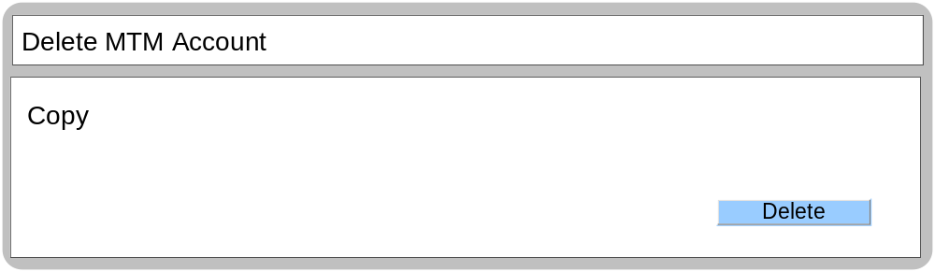

Business Logic Content

Name | Type | Description/Condition
Delete MTM Account | Screen Title | The title of the screen
Copy | Text | To be defined by the Business

Links
Name | Destination | Description/Condition
Delete | Confirm to Delete MTM Account | Leads the user to Confirm to Delete MTM Account

Validation
None

Screen – Confirm To Delete MTM Account
This screen will allow the CSA to confirm the deletion of the MTM account.

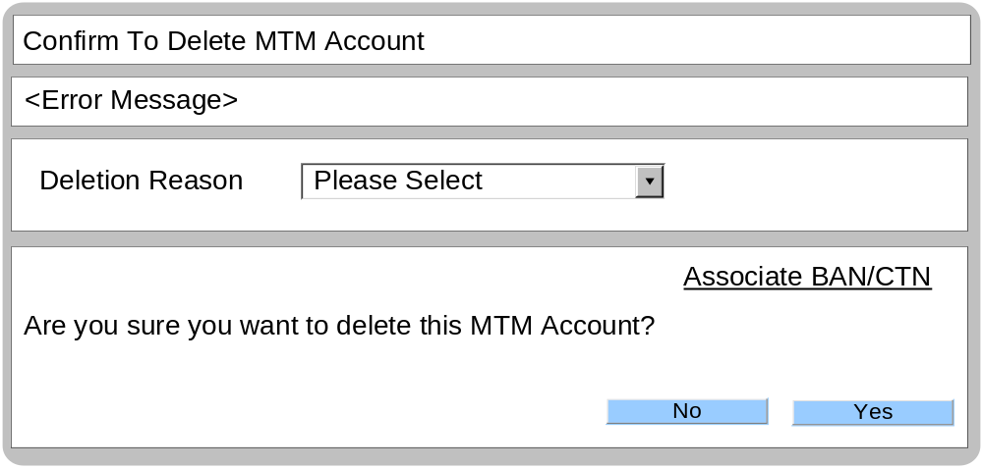

Business Logic Content
Name | Type | Description/Condition
Confirm to delete MTM Account | Screen Title | The title of the screen
Error Messages | Dynamic Text | If the MTM account can not be deleted due to system issues:  Error Message = “The MTM Account can not be deleted, please try again later.”  If a deletion reason has not been selected:  Error Message = “Please select a deletion reason”
Deletion Reason | Drop Down List | A list of all the deletion reasons why the MTM account will be deleted.  List: Please select, Error in Sign Up, Login problems, Elapse User, Test Account, Transfer of Ownership, Closed Account.  Default – Please Select

Links
Name | Destination | Description/Condition
No | MTM Profile | Leads the user to MTM profile screen  The user has opted not to delete the MTM account.
Yes | Delete MTM Account Confirmation | Leads the user to Delete MTM Account Confirmation  This will remove the MTM profile from the system.
Yes | Confirm to delete MTM Account | User has not selected a deletion reason.  Reloads the ‘confirm to delete MTM account screen’.
Associate BAN/CTN | Associate BAN/CTN | Leads the user to the associate BAN/CTN screen.

Validation
Name | State / Response
Deletion Reason | A deletion reason must be selected before the user can progress and delete the MTM account.

Screen – Delete MTM Account Confirmation
This screen will confirm that the MTM account has been successfully removed.

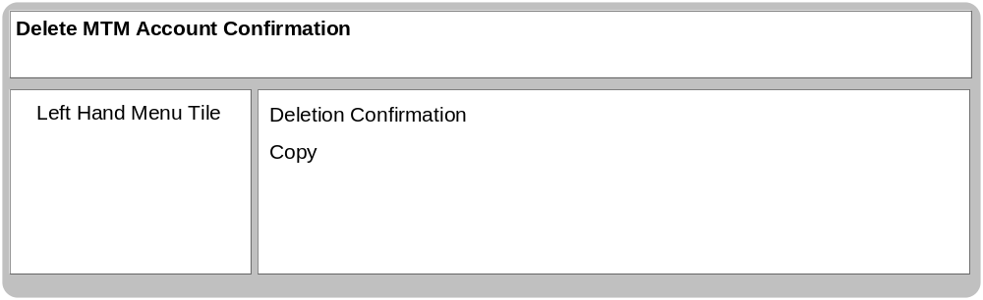

Business Logic Content

Name | Type | Description/Condition
Delete MTM Account Confirmation | Screen Title | The title of the screen
Left Hand Menu Tile
Described within section 1.1.1.2
Deletion Confirmation
This tile is always displayed on the Locate Customer Screen.
Copy | Static Text | To be define by the business.

Links
None

Validation
None

